SAL 213 Module 6 Submission Template

Name: Hunter Geise

Collaborators: NONE. Should work on this solo.

**Module 4, Step 1**:





**Module 4, Step 2, Part 1**:

In the weather model, I think multicollinearity can exist between multiple variables. First, I think it can occur between min/max temp, wind speed/gust, humidity, and the feels like variables. All of the variables mentioned play into what the feels like temperature is. If it is hot and humid, the feels like temp is high. If it is cold with high wind speeds/gusts, the feels like temperature will be low. I also think there can be multicollinearity between the wind speed and wind gust variables because they both involve how fast/hard the wind is.

In the hockey model, I think multicollinearity can exist between the home/away quality and game importance. This is due to high importance game potentially being examples of two high quality teams squaring off on the ice. I do expect there to be a high

**Module 4, Step 2, Part 2**:





**Module 4, Step 2, Part 3**:

Due to getting an error for regressing the interaction term, I did a p-test to see if it added predictive power to the model

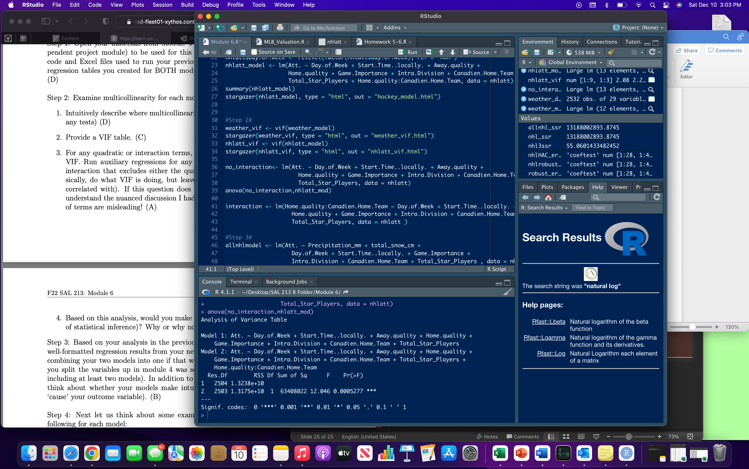

Looking at the p-value in the F test, it is statistically significant, so therefore it does add predictive power to the model.

**Module 4, Step 2, Part 4**:

For the weather, I would drop wind gust, wind speed, humidity, min and max temperature, and feels like because it doesn’t have any effect on transportation which would affect the attendance. People will show up for a hockey game whether it’s freezing out, scorching hot, or when there’s wind that can knock you over.

I would drop the home/away quality because they have a major effect on the game importance VIF. I feel that hockey fans will show up regardless of how good their team is or how good the opponent is, but when the game is important there is going to be a lot more fans.

**Module 4, Step 3**:



**Module 4, Step 4, Part 1**:

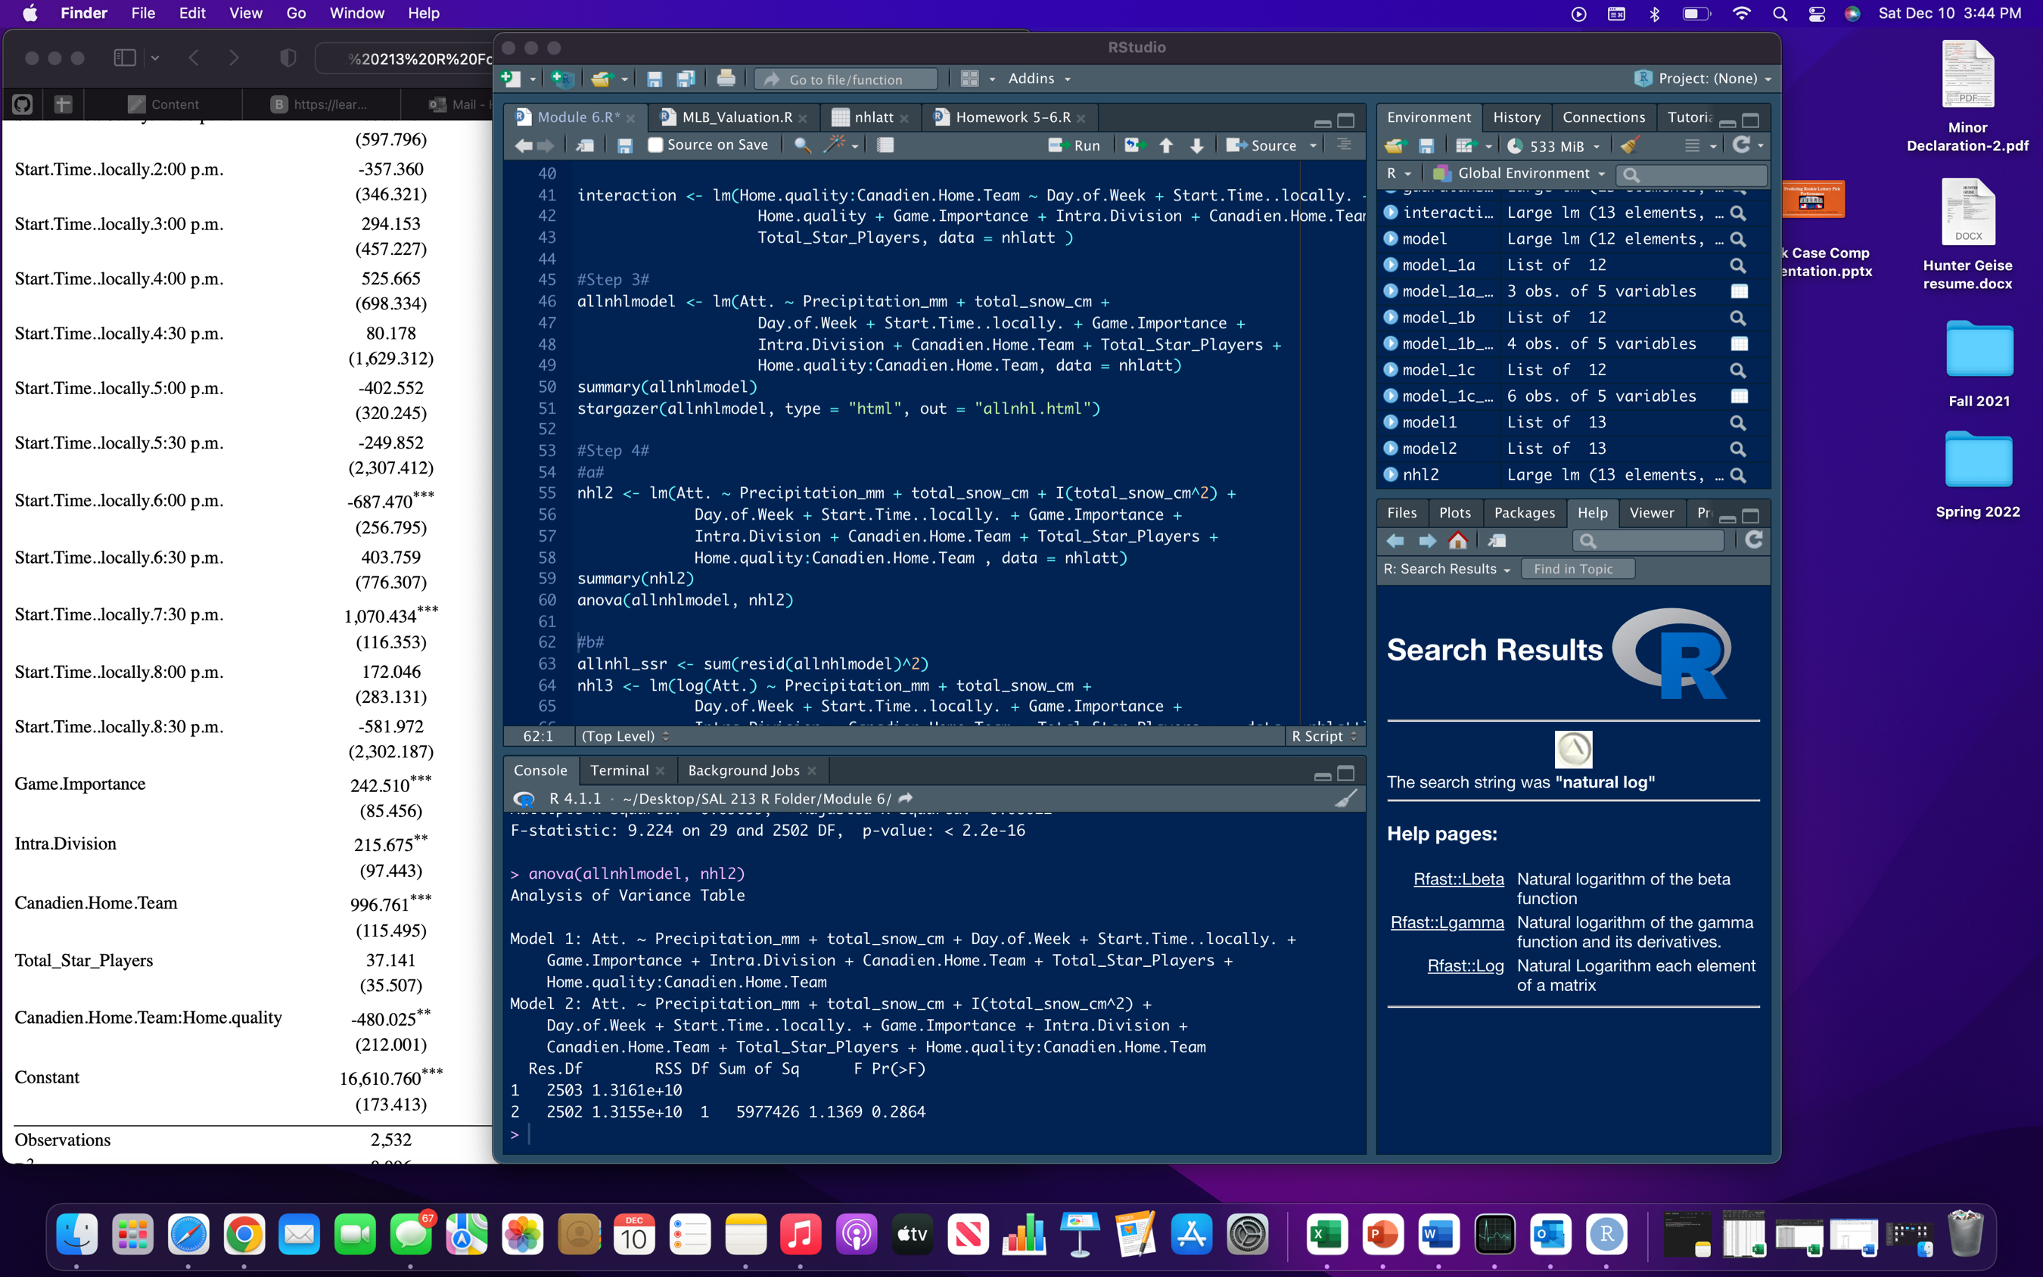

When adding a quadratic to total snow in cm, it does not add any predictive power to my model because it is not statistically significant at the 5% level with a p-value of 0.2864.

**Module 4, Step 4, Part 2**:

Found sum of squared residuals in R and calculated chi squared and chi squared p-value in Excel.

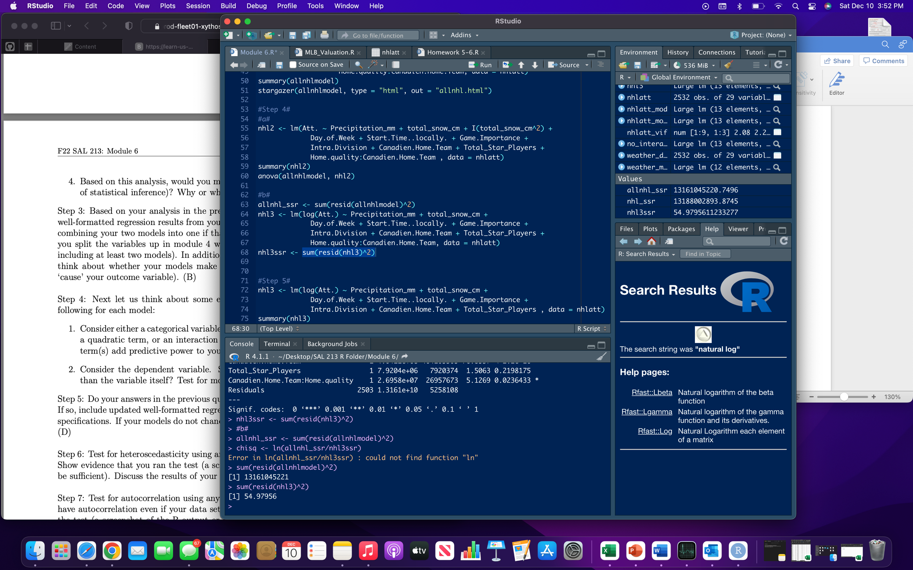

After plugging in the sum of squared residuals in Excel, I got a p-value of 1.12083E-05. Therefore, taking the log of my dependent variable does add predictive power because it is statistically significant at the 5% level

**Module 4, Step 5**:

I am going to take the log of my dependent variable of attendance.



**Module 4, Step 6**:

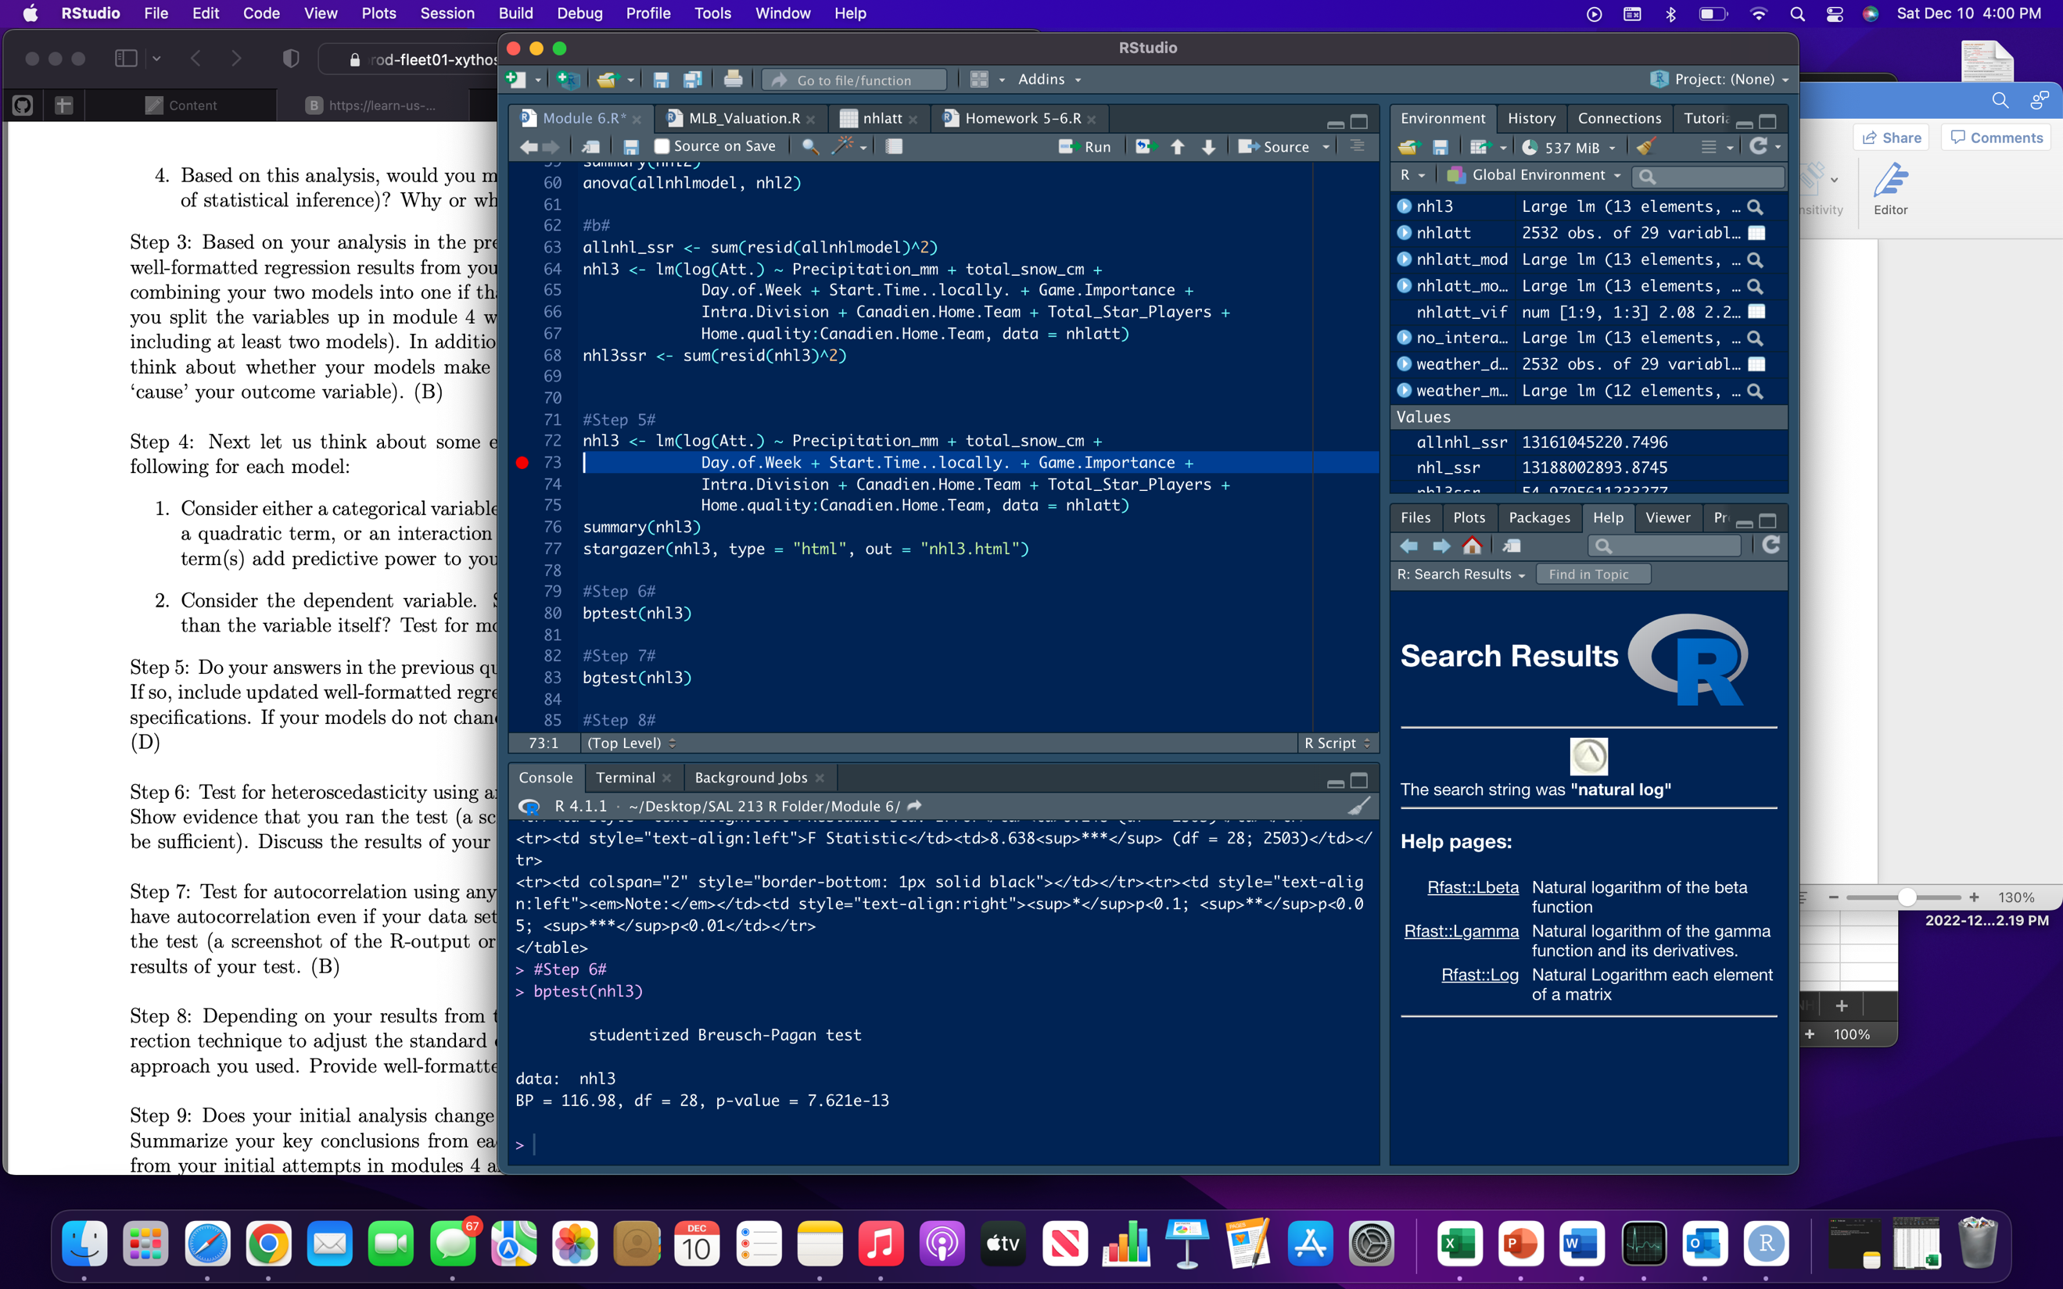

The Breusch-Pagan tests rejects the null hypothesis of homoscedasticity in favor of the alternative hypothesis of heteroscedasticity because of the p-value being 7.621e-13.

**Module 4, Step 7**:

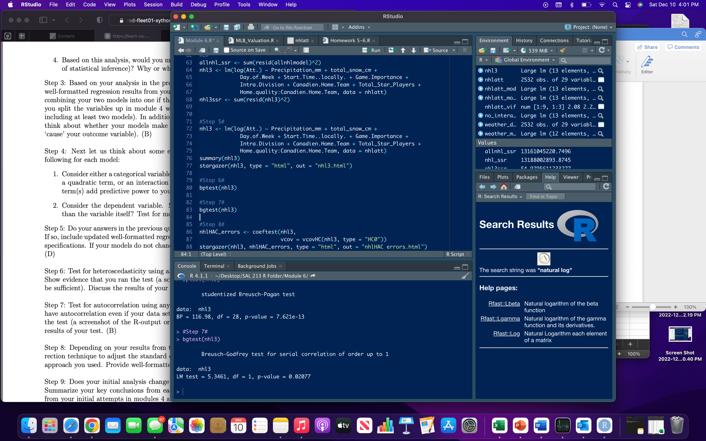

The Breusch-Godfrey test rejects the null hypothesis of no autocorrelation at the 5% level in favor of autocorrelation because of the p-value being 0.02077.

**Module 4, Step 8**:

To take care of autocorrelation and heteroscedasticity I used the HAC Standard Errors.



**Module 4, Step 9**:

With all the changes and tests that were done, the interpretation of all the coefficient estimates changes. Originally going from “a 1 unit increase in X changes Y by the coefficient estimate”, the log-lin model makes the interpretation “a one unit increase in X changes Y by ${ (e}^{β_{1}}-1)*100\%$”. Looking at the weather variables, the coefficients decreased greatly, but were still statistically significant. Precipitation went from an OLS estimate of -13.390 to-0.001 and total snow went from 76.854 to 0.007. For example, an extra inch of snow adds 0.702 fans. With the hockey variables, every coefficient also decreased by a large amount. Originally all the absolute values of the OLS estimators were greater than 50, but they were all under one besides the constant. All of the days and game times from the original model stayed statistically significant at different levels, but new estimators 12:30 start and 8:30 start became statistically significant.

**Module 5, Step 1**:



**Module 5, Step 2, Part 1**:

I think that Base-Outs Runs Saved and Earned Runs can have multicollinearity because both of them involve earned runs that a pitcher can allow. Besides that, I don’t know of any other variables that can have multicollinearity.

**Module 5, Step 2, Part 2**:



**Module 5, Step 2, Part 3**:

My model had no quadratic or interaction term.

**Module 5, Step 2, Part 4**:

I would probably eliminate Base-Outs Runs Saved since it has multicollinearity with earned runs. It also more than likely has multicollinearity with batters faced, innings pitched, and pitches thrown because it takes it play by play which would involve each pitch/batter faced into consideration. I think that would drive down most of the high GVIF values.

**Module 5, Step 3**:



**Module 5, Step 4, Part 1**:

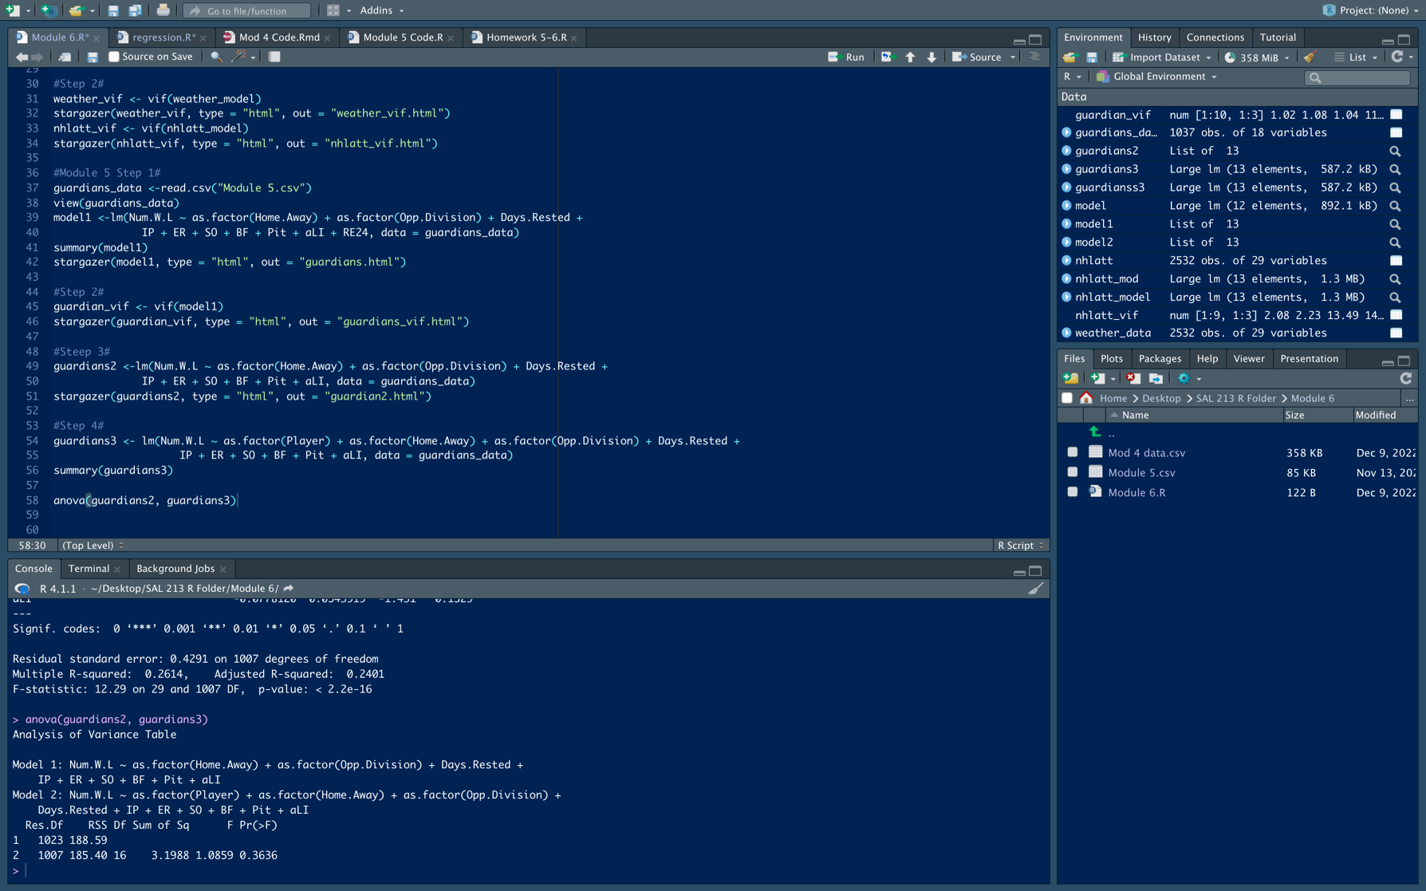

When adding the dummy variable of pitcher, it does not add predictive power to my model because it is not statistically significant at the 5% level with a p-value of 0.3636.

**Module 5, Step 4, Part 2**:

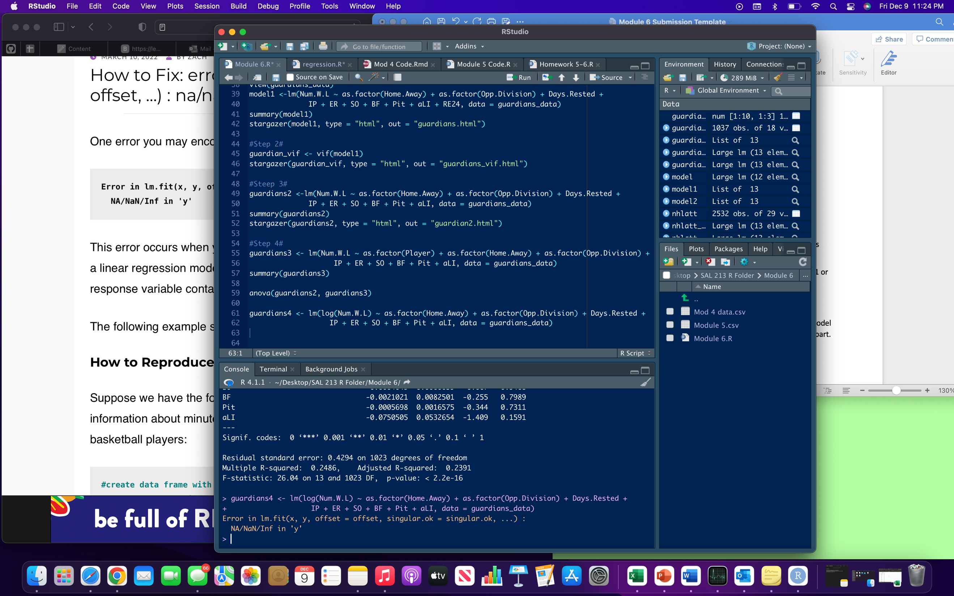

I couldn’t run the log of my dependent variable because my dependent variable is either a 1 or 0, where a 1 is a win and 0 is a loss. Therefore, I will not include the log of my dependent variable.

**Module 5, Step 5**:

My model will remain the same as Step 3.



**Module 5, Step 6**:

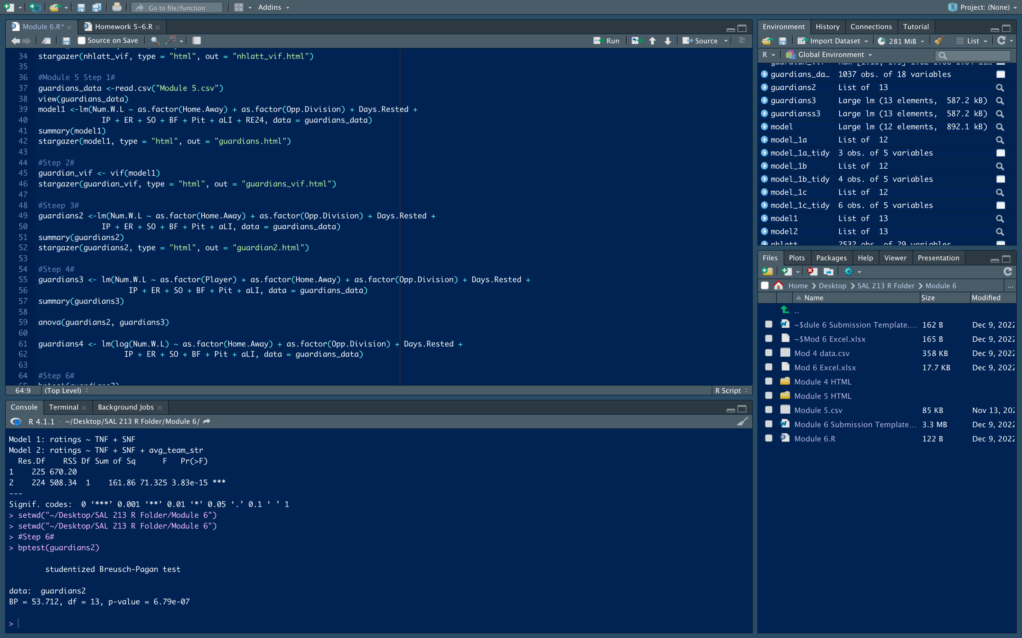

The Breusch-Pagan tests rejects the null hypothesis of homoscedasticity in favor of the alternative hypothesis of heteroscedasticity because of the p-value being 6.79e-07.

**Module 5, Step 7**: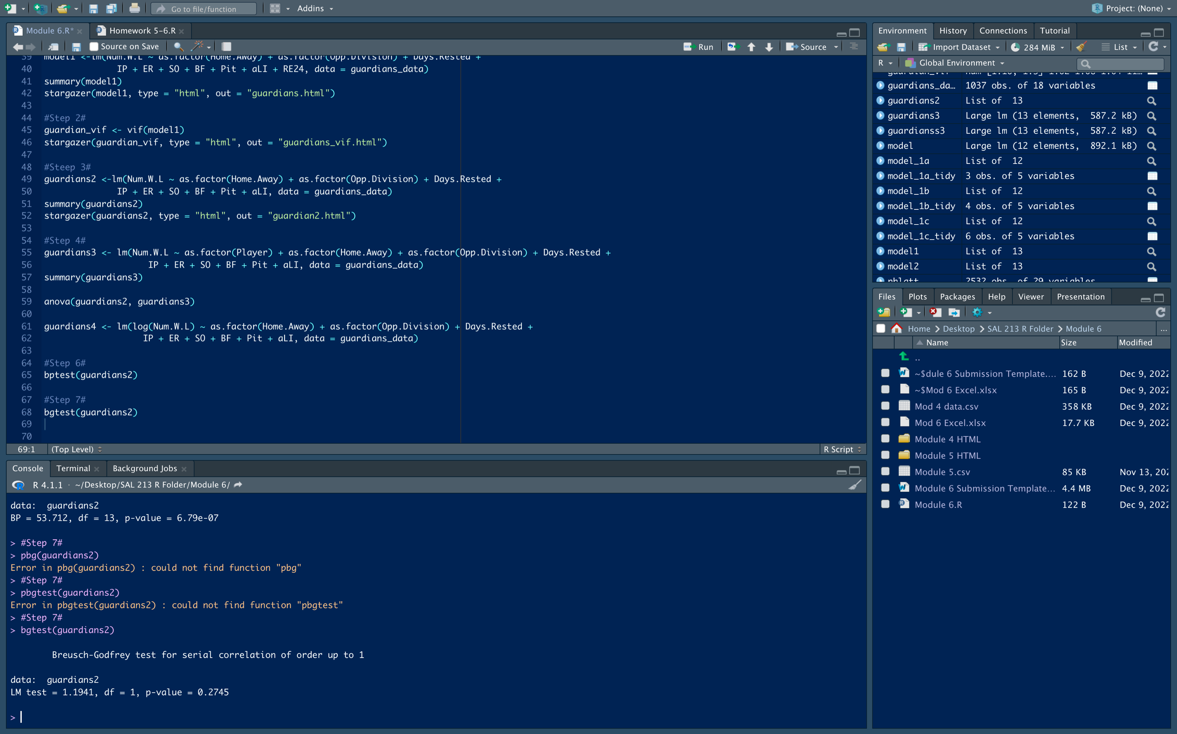

The Breusch-Godfrey test fails to reject the null hypothesis of no autocorrelation at the 5% level because of the p-value being 0.2745.

**Module 5, Step 8**:



To correct heteroscedasticity, I used Robust Standard errors.

**Module 5, Step 9**:

My initial analysis doesn’t change at all. I ended up eliminating one variable (Base-Outs Runs Saved) because it had similar components to other variables in the model that I thought would explain better despite making the model larger. The intercepts and p-values stayed the same, and all I had to do was adjust for heteroscedasticity by using Robust Standard Errors. Like I originally concluded when I first ran this model, there is still much randomness that comes from a team’s hitting and bullpen performance that affects whether they win the game. The constant (Away and AL Central games) and earned runs were both statistically significant at the 1% level in both the normal OLS standard errors and robust standard errors models. AL Central was statistically significant because it is the Guardians division many of their series consist of games within the division, but I’m not sure why away games are significant. Home games were significant at the 5% level in both the normal OLS standard errors and robust standard errors models because approximately half of the games are played at home. Lastly, NL West games and Innings Pitched were statistically significant at the 10% level in both the normal OLS standard errors and robust standard errors models. Innings pitched is statistically significant because a starting pitcher that goes deep into games often leads to the team winning, but I’m not sure why NL West games are statistically significant.